PROJECT SHEET :

Analysis on number of Manufacturers by year

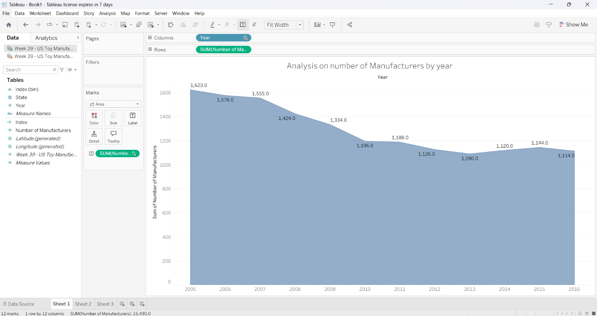

Analysis on Toy Manufacturers in US States by index

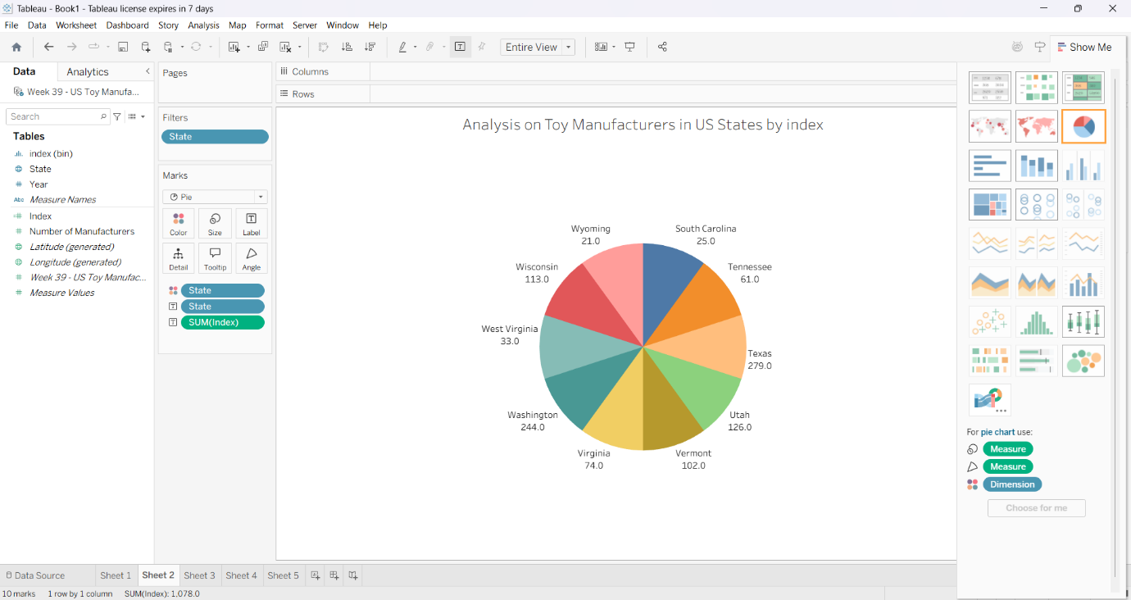

Analysis on Toy Manufacturers by index

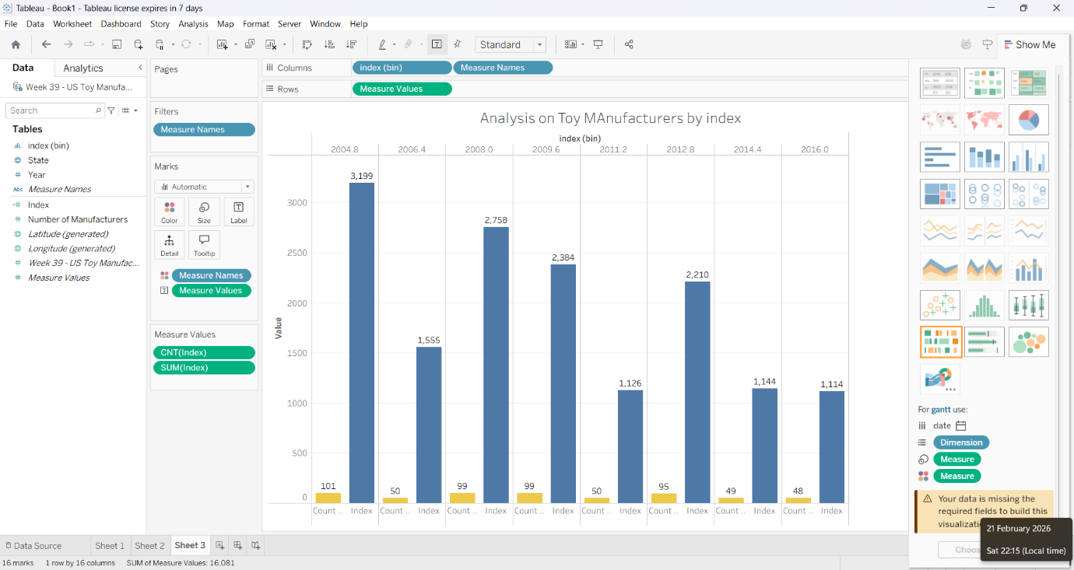

Analysis on Toys Manufacturers

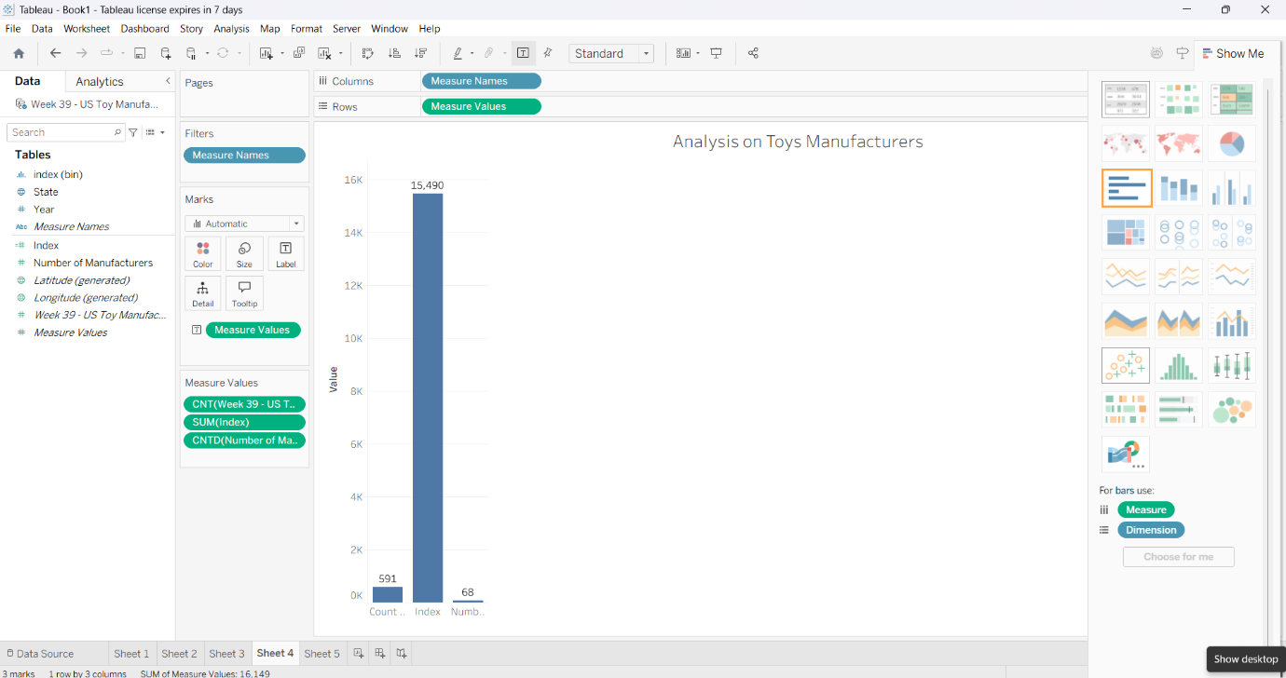

Top 10 state Toy Manufacturers in US States

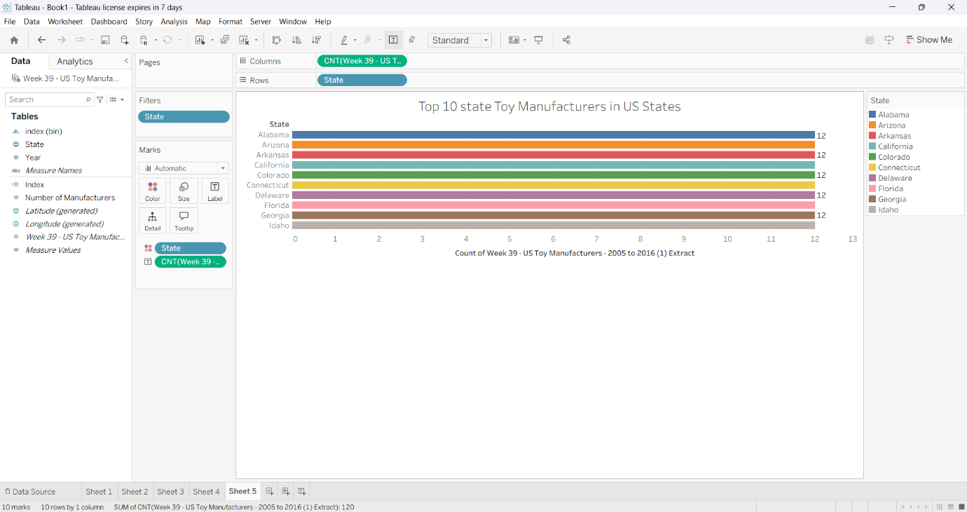

DASHBOARD :

ToyCraft Tales Tableau's Vision into Toy Manufacturing Data
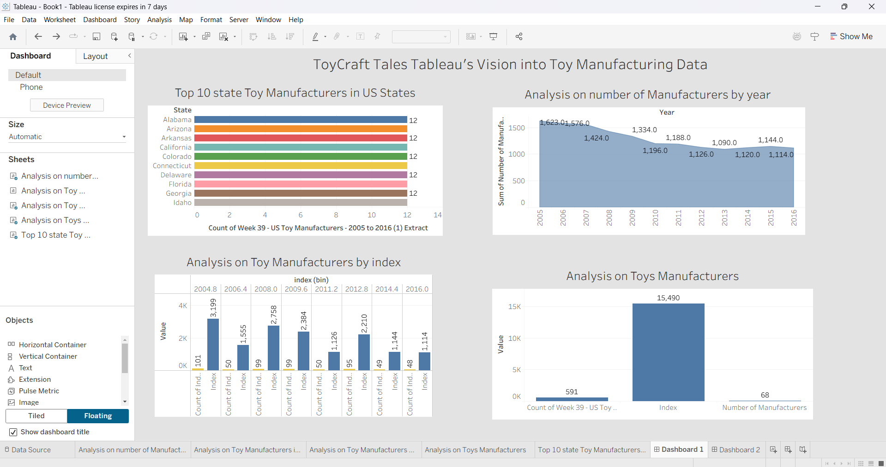

Analysis on Toy Manufacturers in US States by index

